Pilot Instructions

1. Navigate to <http://goto/TLPTool> Be patient as the page loads your employees. If they don’t load, navigate to the top and click on your name and select Manager view.
2. Check to make sure all your employees are listed.
3. Review the information for ALL employees and save your information so the “Last Updated Date” shows that you looked at their information.  If you don’t, you will get reminders until you do.
4. Current TLP Title:  Only your Fellows, Senior PEs, PEs and those with the Technical Leader designation will have a “Current TLP Title”.  Leave everyone else blank.
5. For your TECHNICAL employees only, choose a Domain and Sub-Domain.  Use the [Technical Domain Definitions](https://sp2010.amr.ith.intel.com/sites/LearningDevelopment/_layouts/xlviewer.aspx?id=/sites/LearningDevelopment/Documents/Tech-Domains-Definitions.xlsx) to help guide you.  If you want additional guidance, visit Degreed inside MyLearning and take the Technical Domain Training in the Technical Leadership Development [Pathway](https://degreed.com/pathway/je9kkn2o9o?path=technical-leadership-development--tld-).  For non-technical employees, leave it blank.
6. Fill in the area of expertise.  Be as specific as you can be by starting broad and then drilling down.  E.G.  Software – Driver Development.  Please do this for ALL employees.
7. Select Yes or No for Written Individual Development Plan, whether or not you’ve reviewed it, whether or not your boss has reviewed it.  Please do this for ALL employees.
8. Answer Yes or No for whether or not you expect / or they want to get to Principal Engineer at some point in their career.  This is critical to building our pipeline.
9. Select the YEAR you think you might nominate them for PE.   If it’s past 2026, leave it blank.
10. Click Save.  Work on your next employee until you are done.  Be sure to click save after each one.
11. When done, make sure all employees have today’s date in the Last Updated column. You are welcome to download your information by using the Export to Excel button.  If you have any issues, use the button in the bottom RIGHT to “report a defect”.
12. You’re DONE!  Thank you for helping us build the pipeline!

Starting the application

1 Open Chrome** and go to the following URL, http://goto.intel.com/TLPTool.



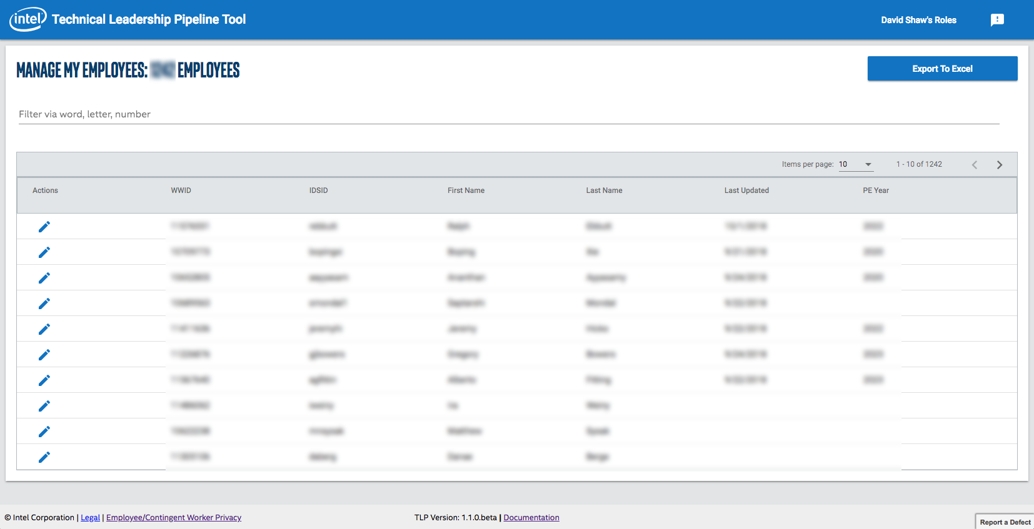

2 You should automatically be logged in. The screen may take a second to load data, but then you will see something similar to this (see the image on the right).

Get to know the app

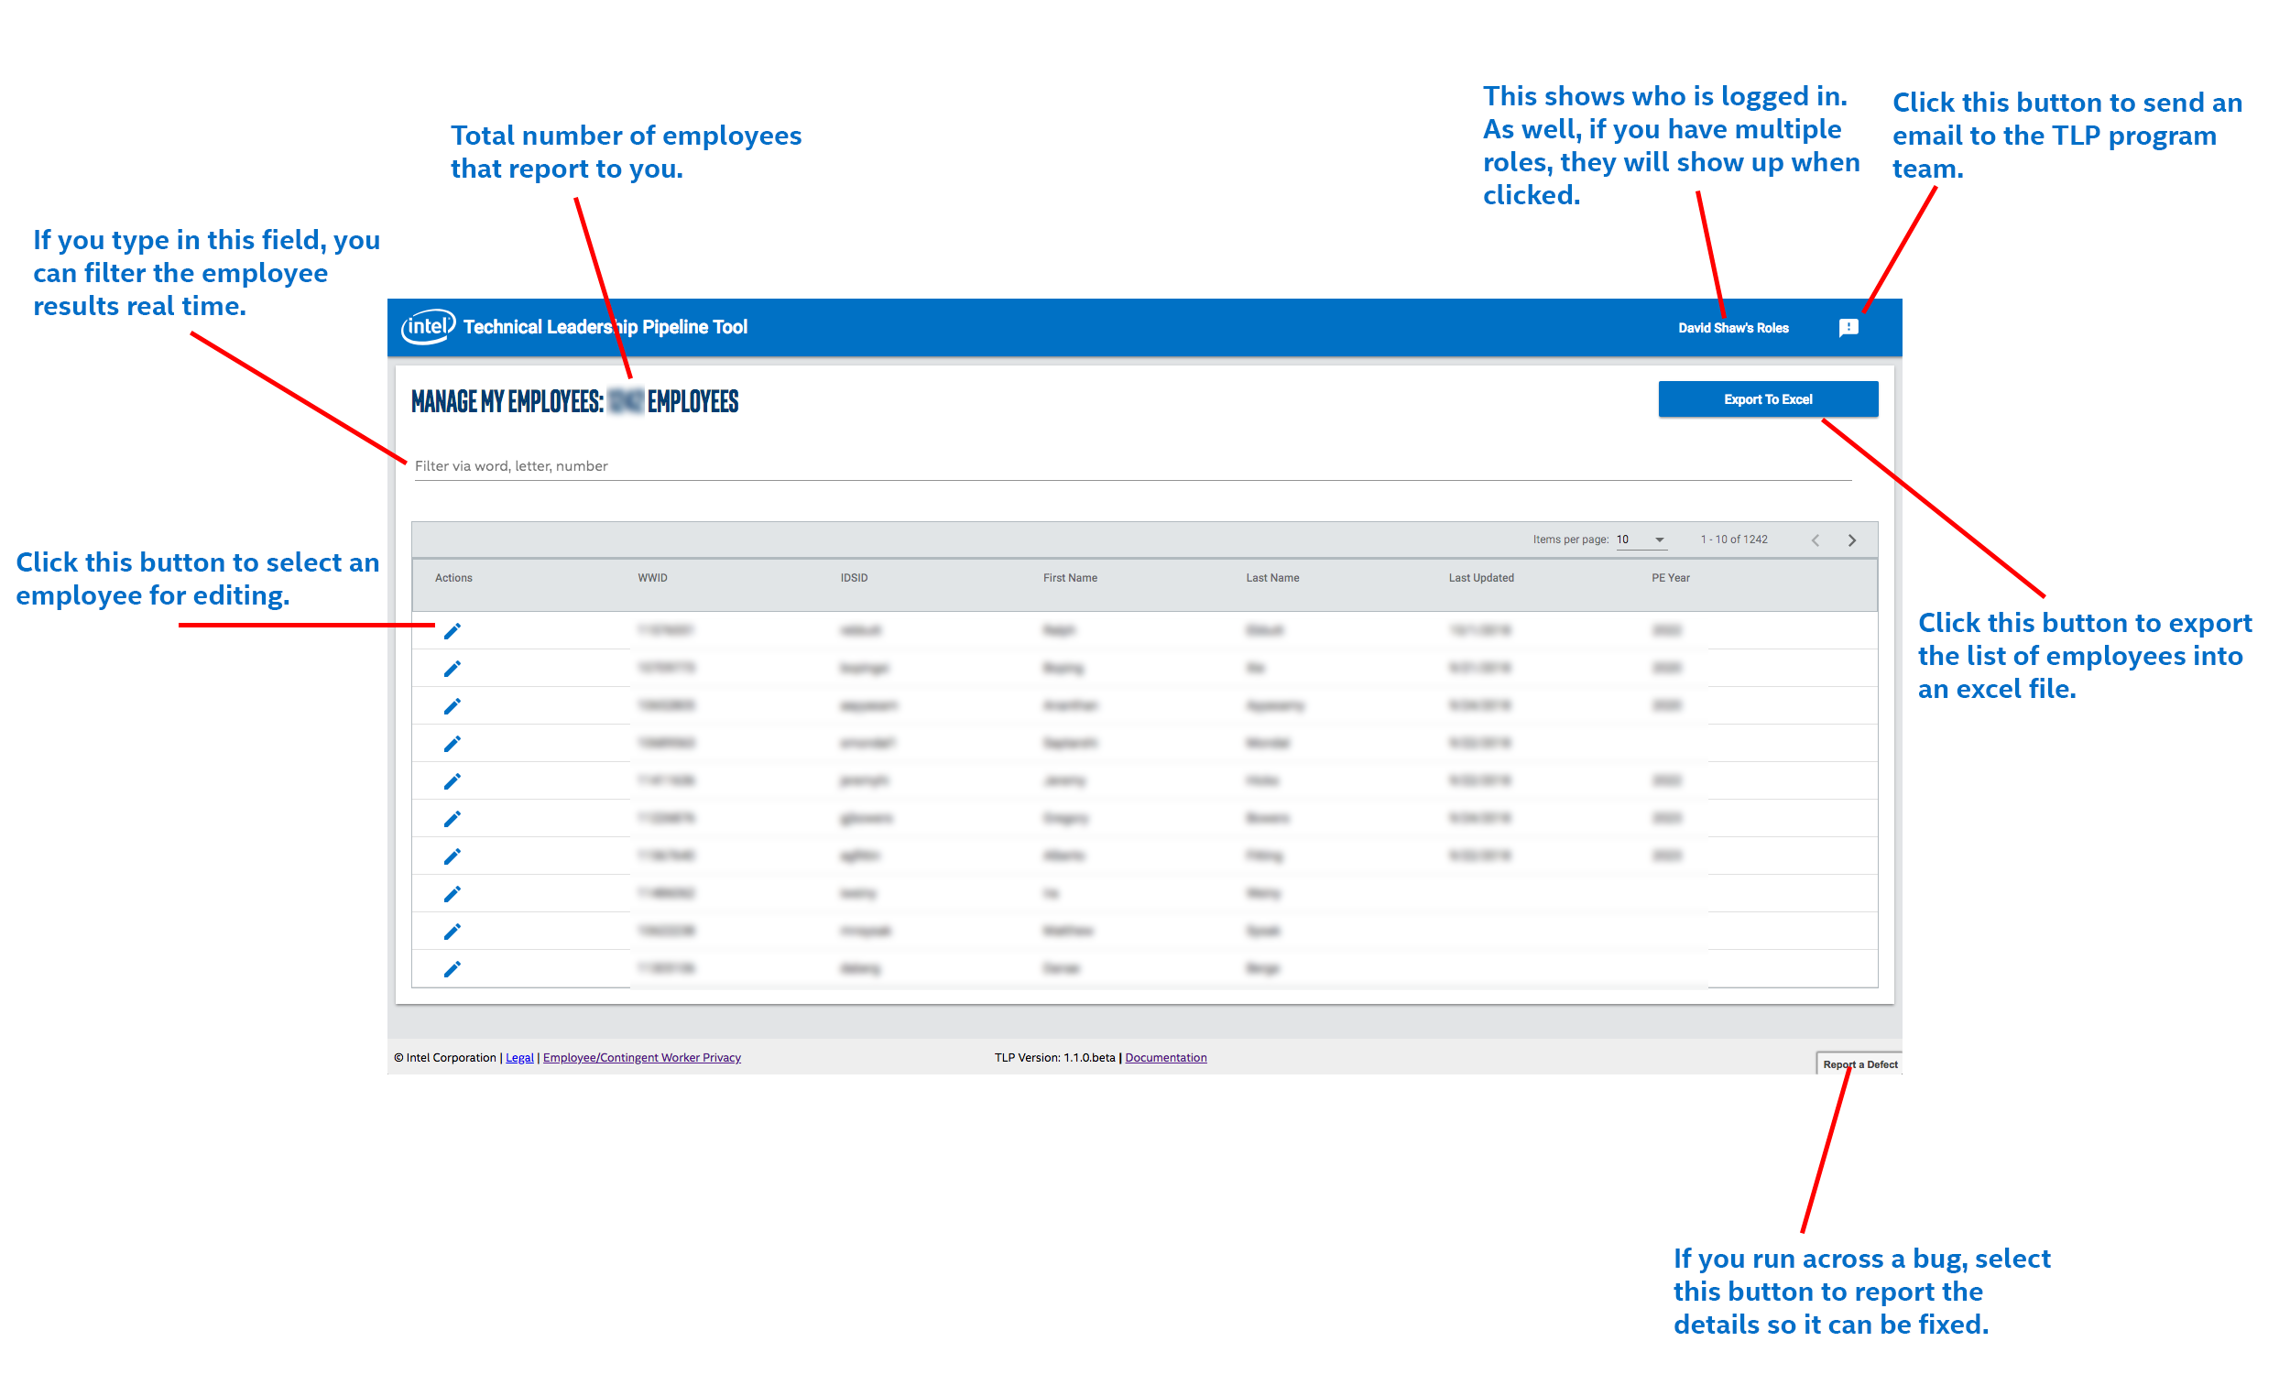

3 Job Signup Button - This is the magic button into the world of Jobs!

Editing an Employees Data

[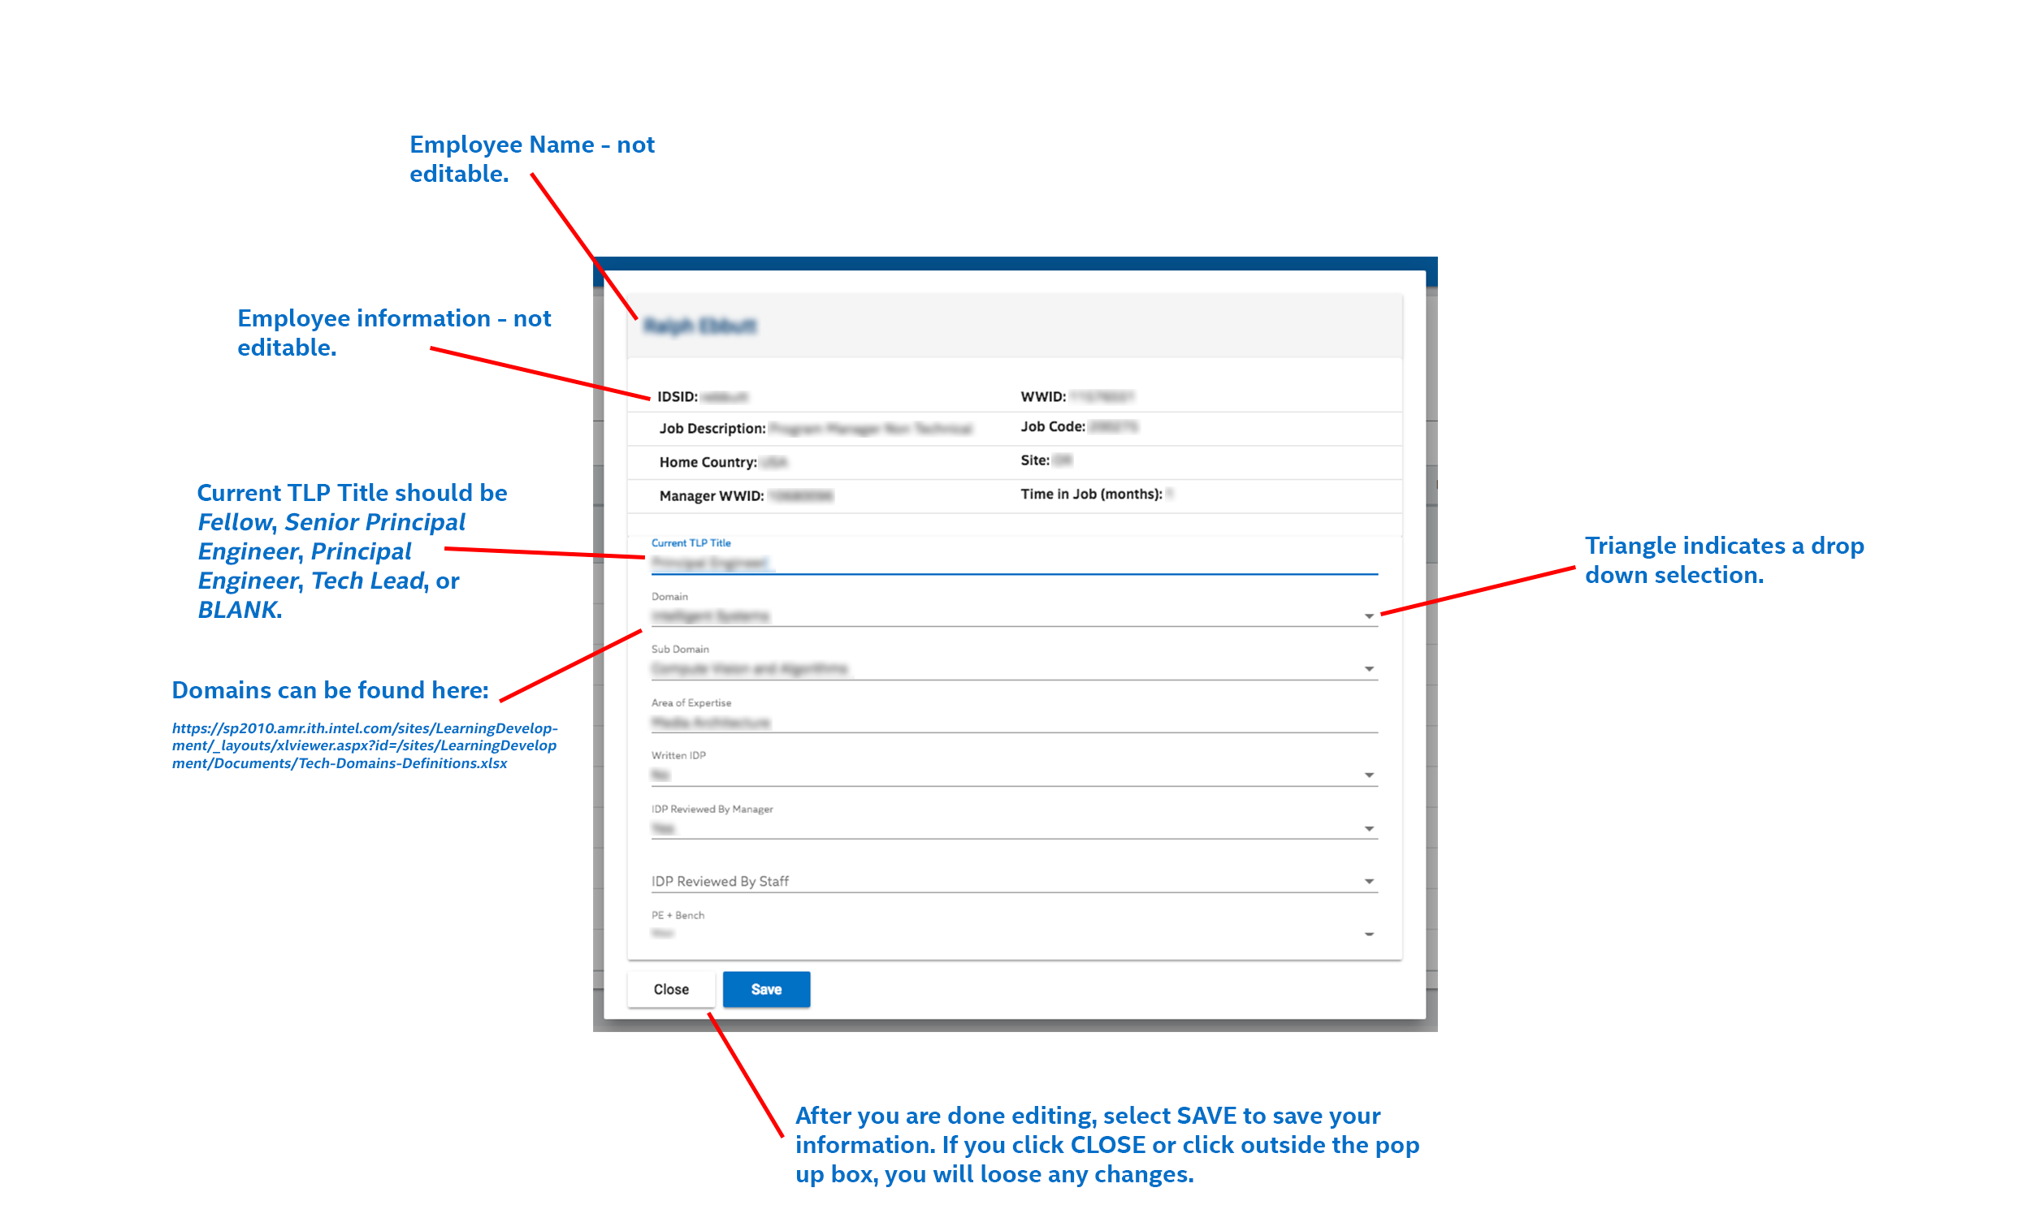](https://sp2010.amr.ith.intel.com/sites/LearningDevelopment/_layouts/xlviewer.aspx?id=/sites/LearningDevelopment/Documents/Tech-Domains-Definitions.xlsx)